Project assignment

# Online store about CD’s

# Project team members

The Development lead is Branimir Petkov. The lead of Design and Art is Viktor Perov. And the project manager is todar mahailof. Communicate well with them in the issue tracker (JIRA, Trello, GitHub) and address issues to the relevant department.

# Software requirements

Introduction:

Purpose:

The purpose of this document is to present a description of Online Store Application (called Online Album Store )

Scope:

The document will cover the basic functionality on high level regarding the Online Album Store. The user-management system, the Orders creation and operation and its respective details. The administrative part – what the special user (Administrator) is not in the scope.

# Overall description

System environment  
  
The store has three actors. All of them can access and do their part from all over the Internet. The users can be unregistered and registered. The unregistered user can access the basic info of the site: see products and their details, categories and pictures of the products. The registered user can access the CRUD operations of their orders: create and edit an order, add the details in the order, delete the details, rate products, write reviews as well.

## Vocabulary

Product page ​– A product page is the main information block regarding a product. It consists of the Product Name in the middle. Like and Add to cart buttons. Should contain Product price in USD, also if discount is available. And a cover image/s on the very right side. Form for leaving product rating (should be available by adding/removing starts). Additional information about the product can be seen below. In order to improve our sells, we should suggest what are products the rest of the users bought in a “People who bought this item also bought” section.

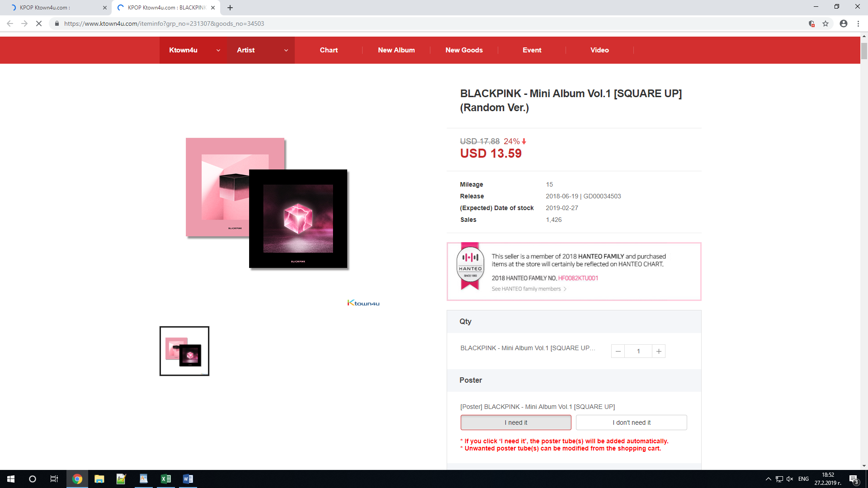

## Simple view

The simple view is a short block of information that displays a photo of the content and short summary of the information that the current content(item) has. This includes the price, the producer, the current sales and quantity.

## Latest products view

This view consists of five of the most recent albums bought a small image of theirs and a text “View details” that is a hyperlink to the product page of the current item.

# Functional requirement specifications

## Use case 1(Accessing the system)

The system is accessed through the internet from its initial URL. It loads header, navigation bar and a home page.

## Use Case 2 (Navigation bar)

The navigation bar has navigational hyperlinks to the Home, Product category, Services & Support, All Products. As well as it should have navigation to the Checkout and My Account pages.

### Navigation bar(not registered)

When the visitor is unregistered the navigation bar has a menu with a hyperlink navigation to Log in/Register pages. When the visitor is registered, hyperlinks to My Account/Log out should be present instead

## Use Case 3(Home Page)

The home page shows the Product block in order of most recent uploaded to the database and the most recent bought(Latest products view).

Use Case 4(Products category page)   
Information regarding the sub-categories is shown as links (e.g. Albums, Merchandise) in the navigation pane, where user can choose where to go next. If the product is not in the database, it should display an “apology” or an error, showing that the product is not available at the current moment

## Use Case 5(Services & support)

Information regarding what the company can offer as an extra services for the customer. The user should be able to navigate to the Services & support page.

## Use Case 6(Add product to cart)

When the user is on the product page and he likes the product and wants to buy it, there must be a button “Add to cart” which adds the current product to the User’s cart. The cart can hold X amount of products that all can be bought by the user.

There are two options when a product is added: Go to cart / Continue shopping

When you go to your cart, it should display the products, the User has added. He should be able to see details about the product, add quantity and even remove a product from the Cart. Clicking on Continue button leads to “Info” section where the User gives information about his address, names, location, delivery type and payment type.

Review and purchase section displays information about the costs of Total Shipping, Item Cost, Item Cost and Total Price. If everything is validated, the user is taken to the next “Final” section. Here user can finally review and approve the product order

## Use Case 7(All Products)

Clicking on the “All products” hyperlink from the header navigates to the All products page. For any user, we show Simple views of random products. Each Product name is hyperlink, leading to product page.

Use Case 8(My Account)

Clicking on the My Account hyperlink from the header navigates to the My account page. Page lists the available sections:

Purchase history

My account – Purchase History

This My account hyperlink navigates to the Purchase History page. Here we show all transactions for the current month. If there are no such transactions - just inform the user with a friendly message.

My account – Your Details  
This My account hyperlink navigates to the User details page. Here we allow edition and update of the Billing/contact details and Shipping Address.

Use Case 9 (Search)  
Clicking on Search from in the header allows for product finds by given keywords. If we have such products, we should show a list with the results. If no product is found, we should display error message stating that “The searched query isn‘t found, please try something else”.

Shefe ot 8 sum na raid puskai ni inache shte se grumna, trqbva da vzema qkata bronq, ama ne bronq ami wrist, trinket x 2 I weapon mi trqbva samo te sa mi pod 400, vsichko drugo e 400+